

SCHOOL OF COMPUTING AND INFORMATICS
BACHELOR OF SCIENCE IN INFORMATION TECHNOLOGY
UNITE TITLE: ETHICAL HACKING
UNITE CODE:
PROJECT TITLE: SECURITY AND ENUMERATION

SUBMITTED BY: MAINA JOSHUA
REG. NO: BSCCS/2024/47667

SUPERVISOR: MR. MICHAEL NYORO

Contents
1 PROJECT TITLE: SECURITY AND ENUMERATION 2
1.1 Selected Technologies 2
1.2 Online portfolio 2
1.3 Importance 2

PROJECT TITLE: SECURITY AND ENUMERATION

Selected Technologies
- Nmap
- Burpsuite
- WHOIS
- DNS LOOK-UP
- Shodan
- DNS Checker

Online portfolio
Github
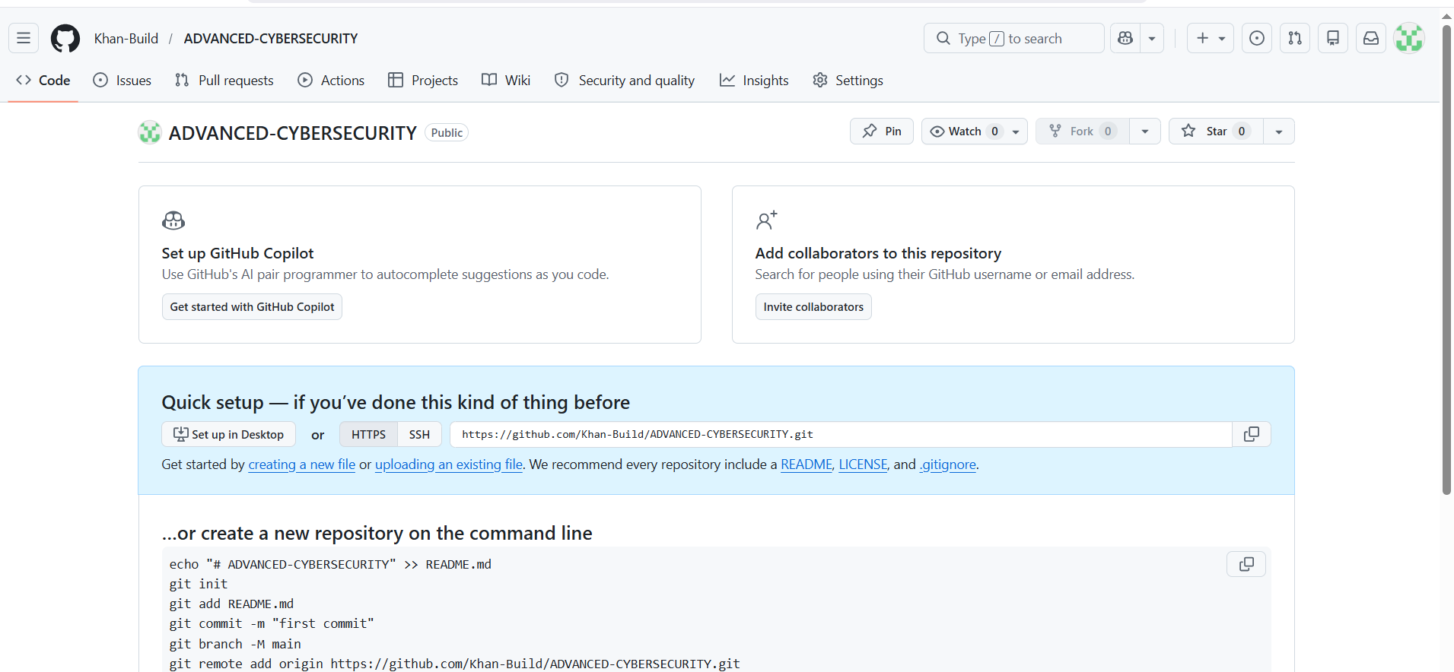
Figure 1Creation of Github Repo
https://github.com/Khan-Build/ADVANCED-CYBERSECURITY

Importance
This Encourages:
- Identify active hosts on a network.
- Discover open ports and exposed services.
- Determine operating systems and device types.
- Identify technologies used by websites and applications.
- Detect outdated software and unsupported systems.
- Map the attack surface of an organization.

Week 1

CRYPTOGRAPHY ENVIRONMENT SETUP
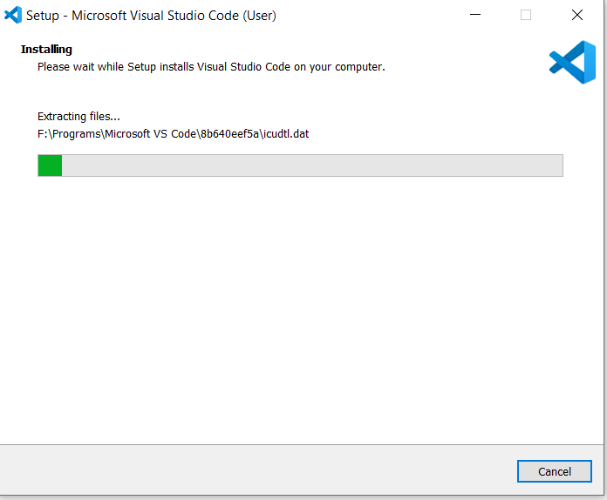
Figure 2Installation of VS Code
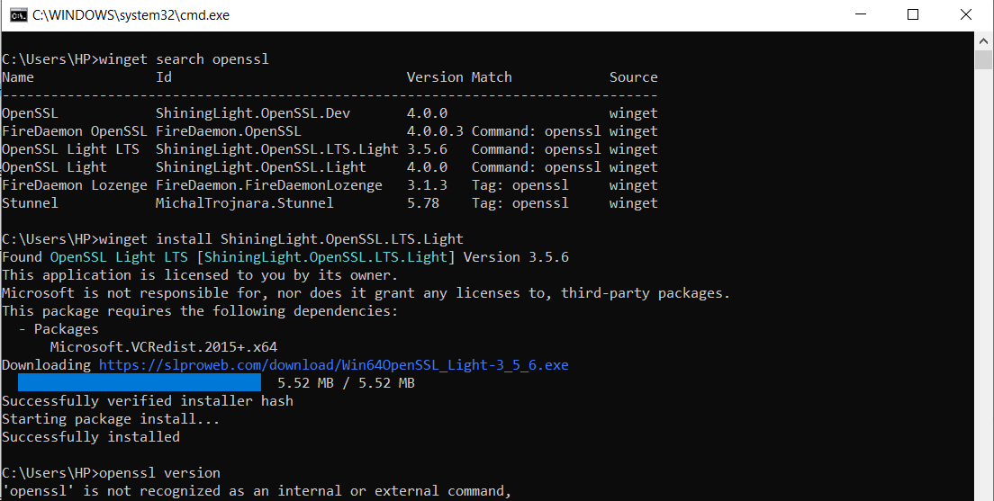Figure 3:open SSL Installation Test
Figure 4Local Encryption Script Execution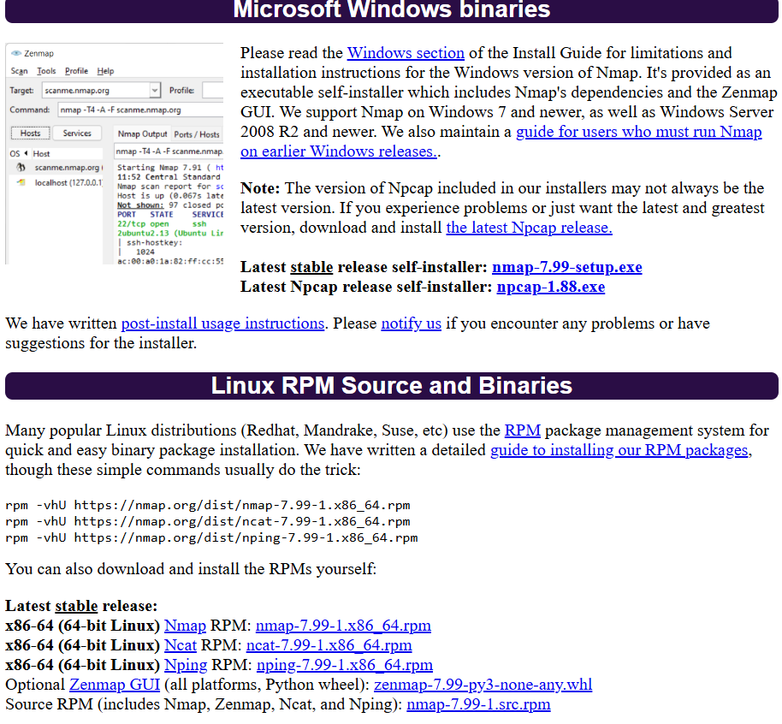
Figure 5Downloading tool from official Site
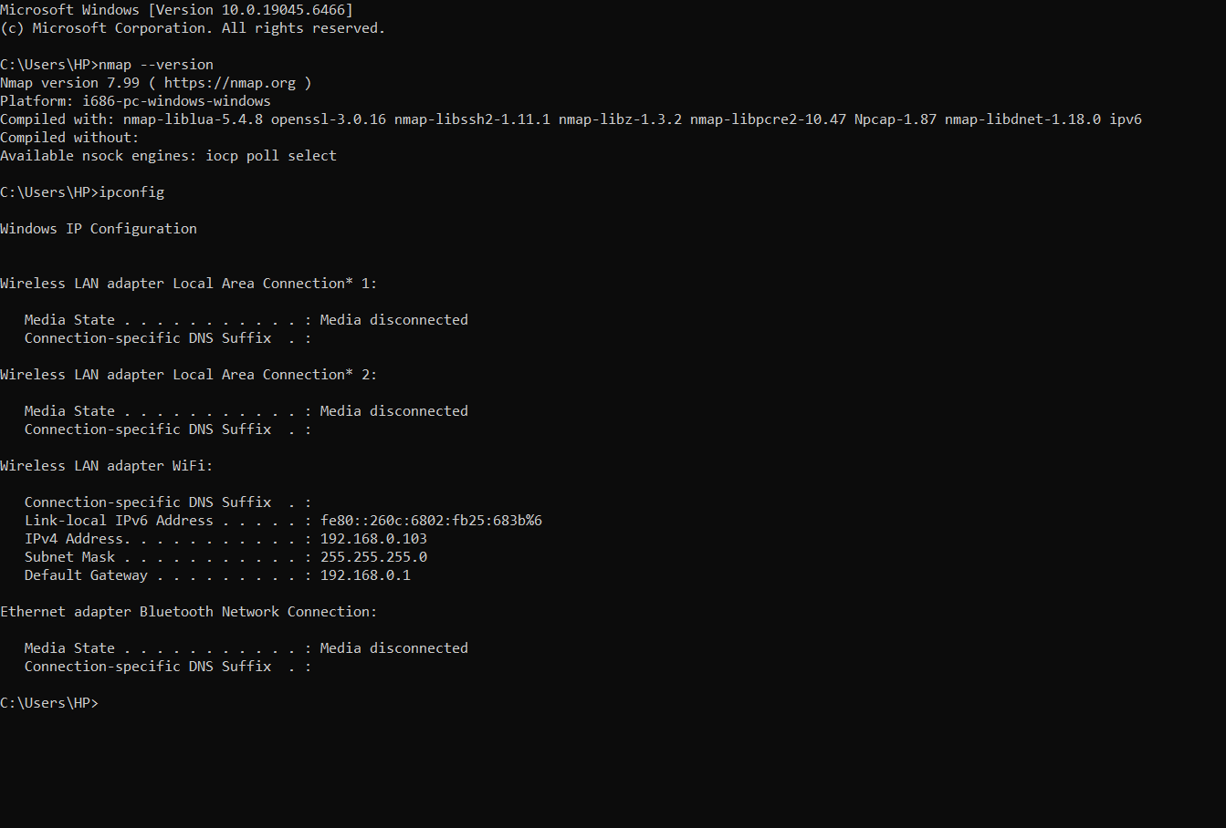
Figure 6 First Scan and confirmation of installation

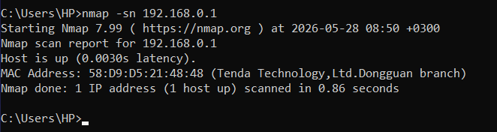
Figure 7 Computer Scan
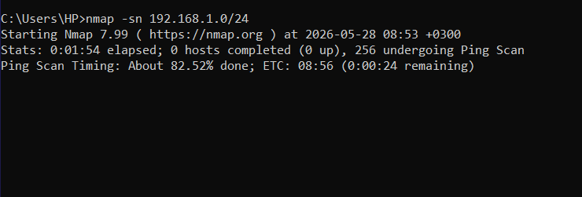
Figure 8 port scanning Nmap.org
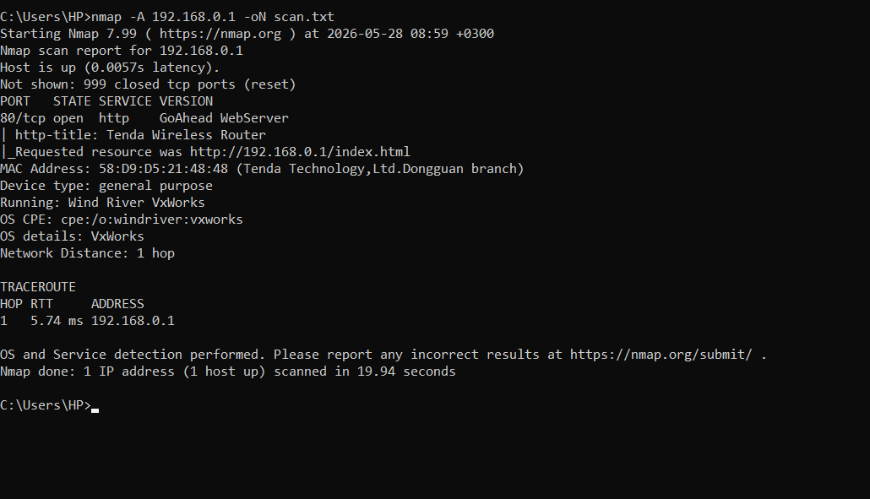
Figure 9 Nmap Report

WEEK 2

Security and Enumeration
ECITIZEN website as a Case Study
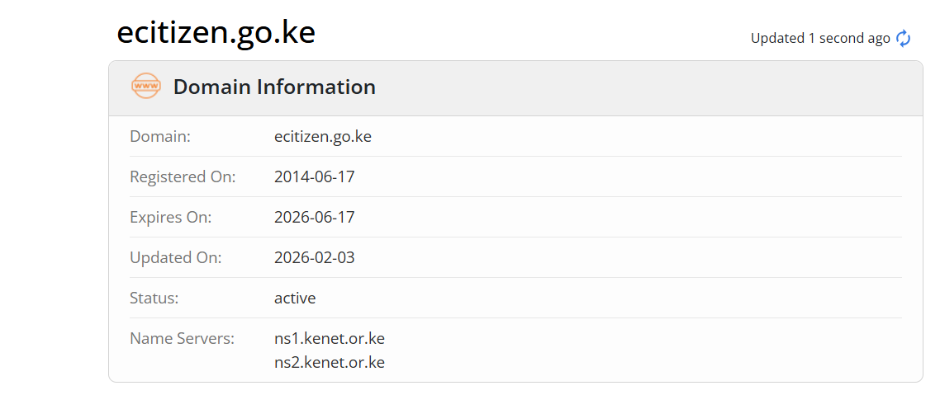
Figure 10 Domain Information
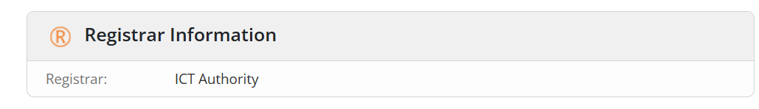
Figure 11:Registrar Information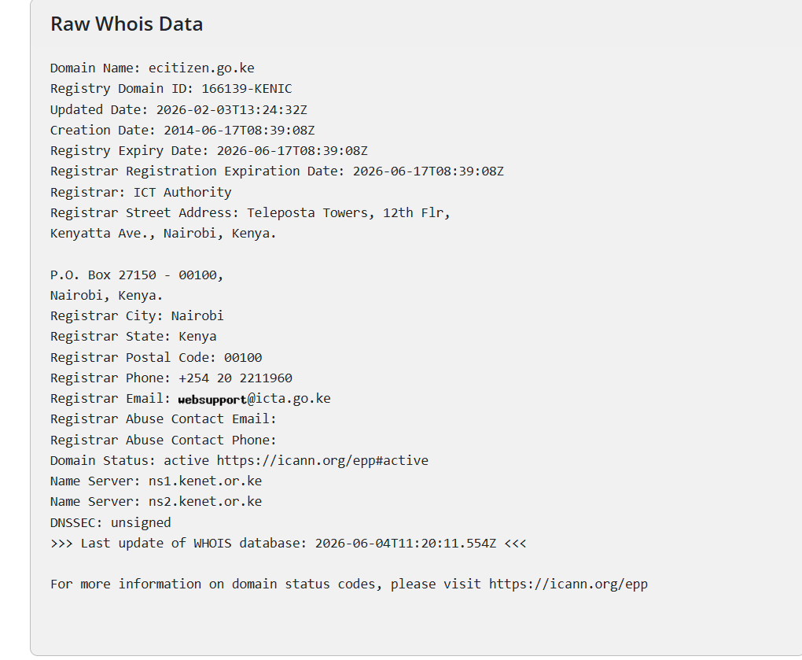
Figure 12Raw Data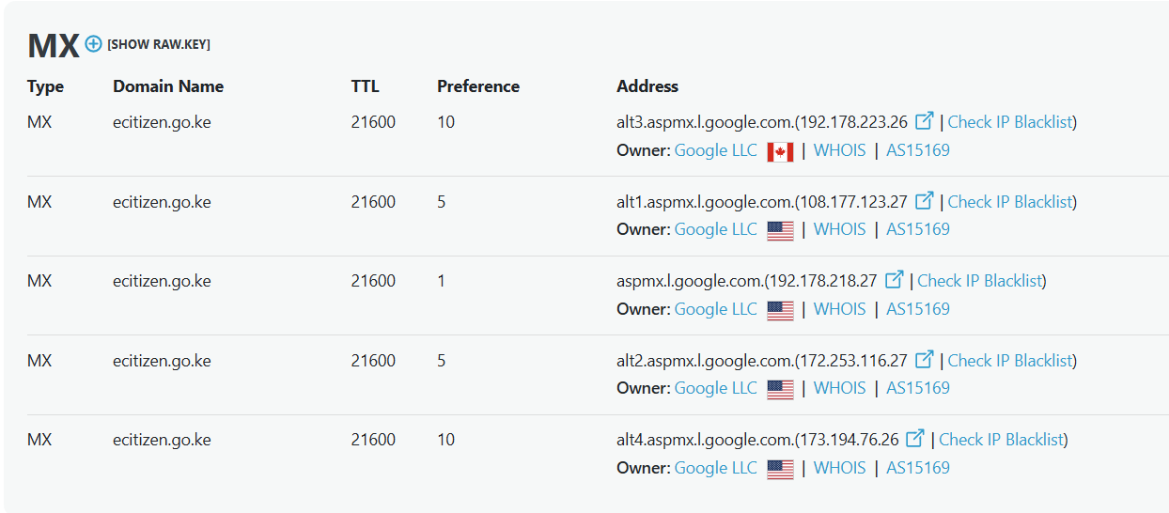
Figure 13:DNS LOOKUP
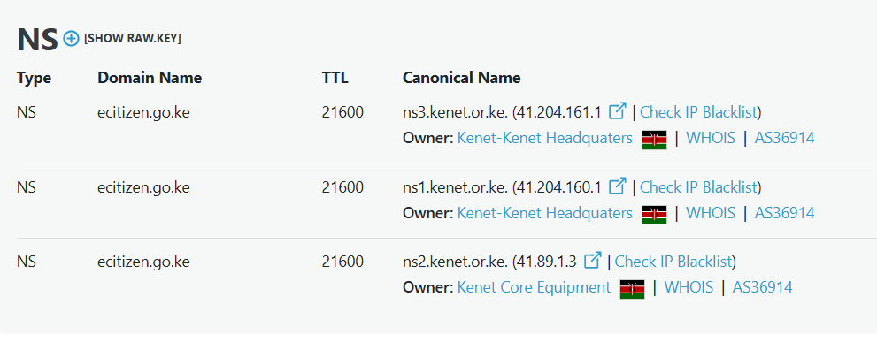
Figure 14:DNS LOOKUP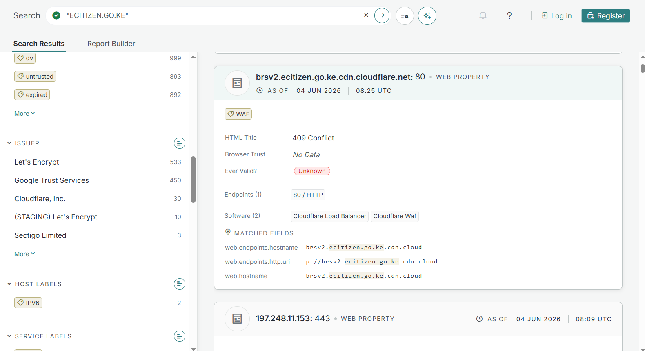
CLOUDFLARE ECITIZEN CERTIFICATE
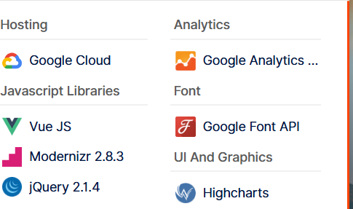
Figure 15 Identifying what tools ecitizen uses
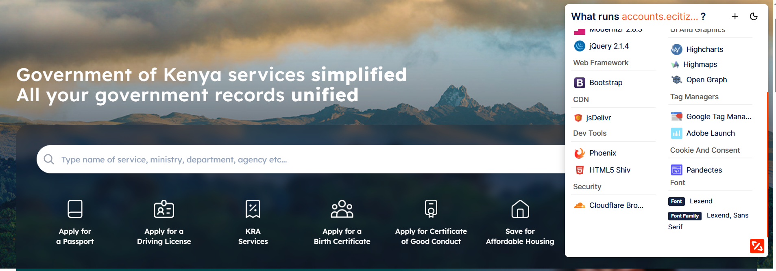Figure 16 ECITIZEN TECHNOLOGIES

WEEK 4

Vulnerability Scanning on OWASP juice shop

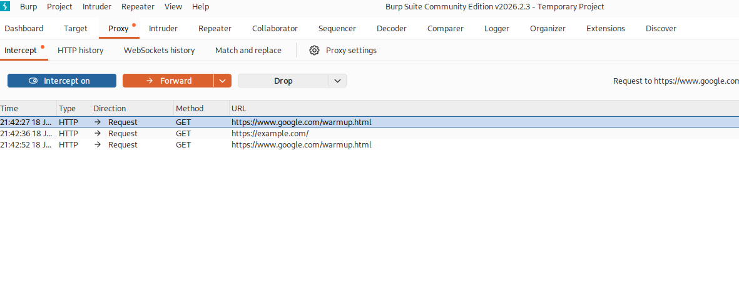
Figure 17 Running burpsuite with testing of example.com
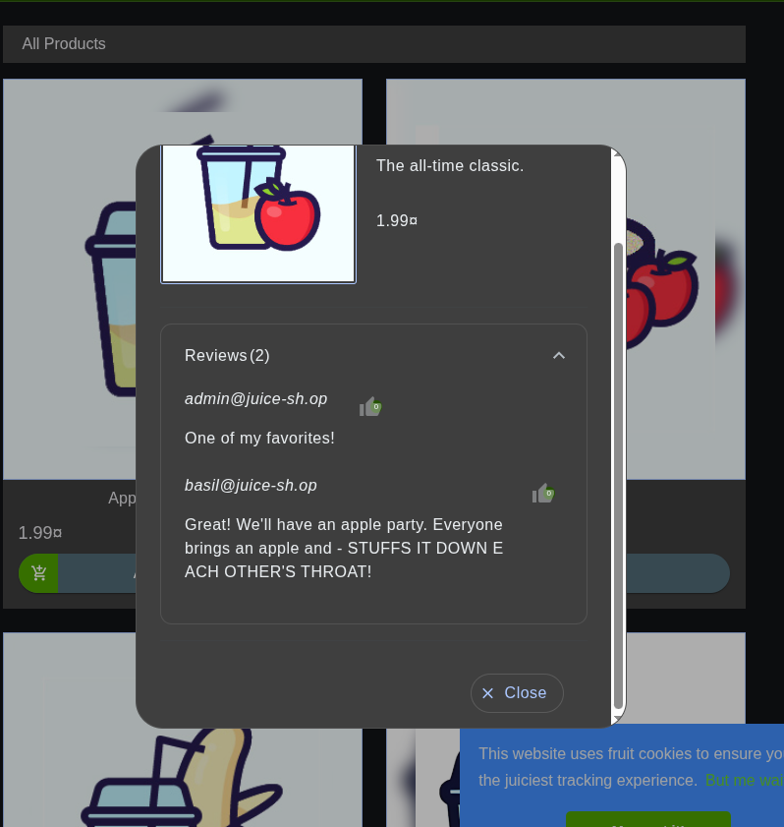
Figure 18 Identifying Admin personal information including admin email
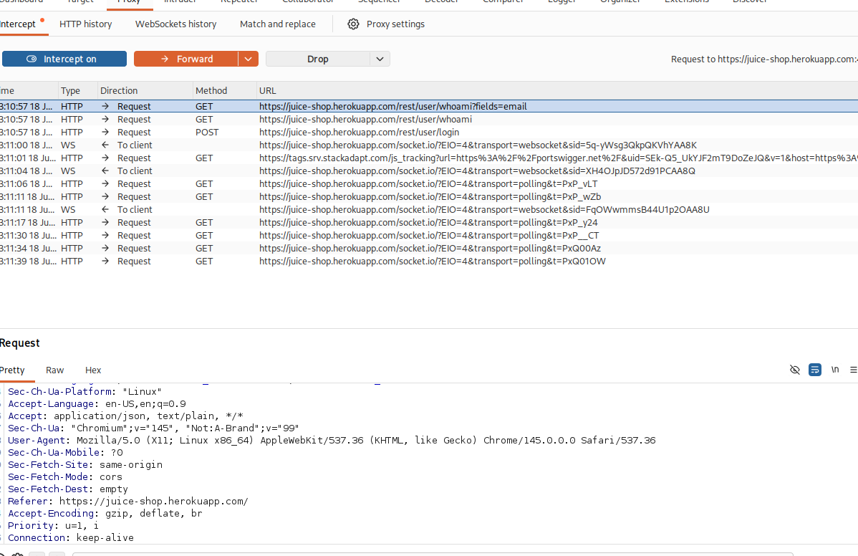
Figure 19 Running Burpsuit with an active intercept on on configured web browser

Student reflection
This exercise improved my understanding of web application security through scanning, discovery, and data enumeration. Using Burp Suite, I identified exposed information and potential vulnerabilities, enhancing my practical skills in vulnerability assessment and reinforcing the importance of securing sensitive data.

WEEK 5

Exploitation of the case study website Juice Shop
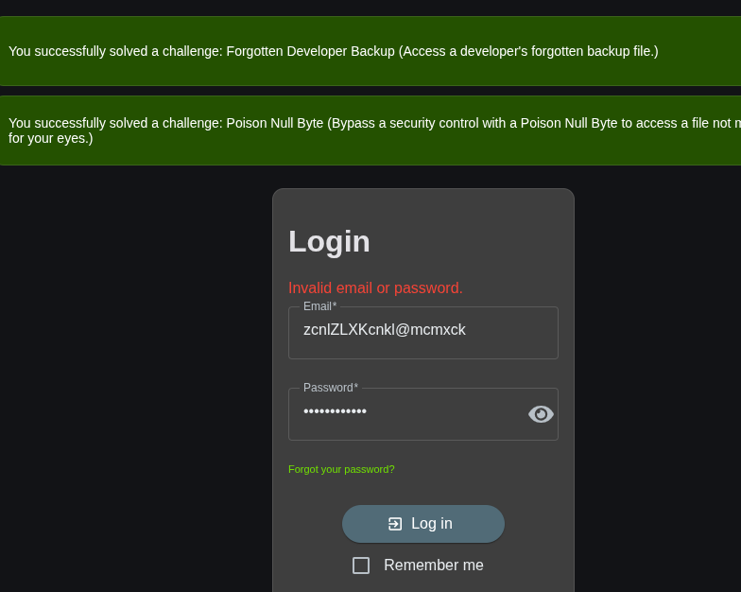
Figure 20 Attempts at brute force of the login page
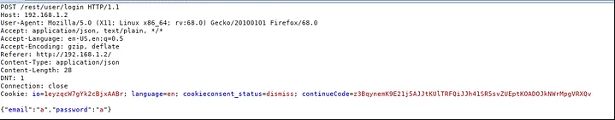
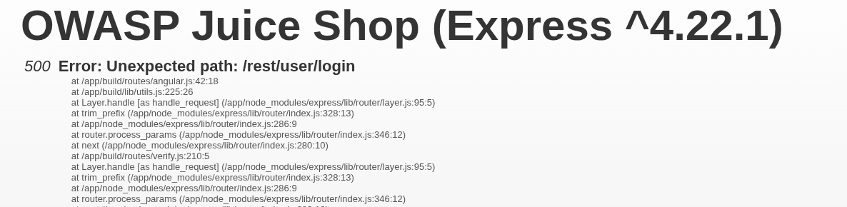
Figure 21 identified SQL error and ability to manipulate

Blind SQL injection
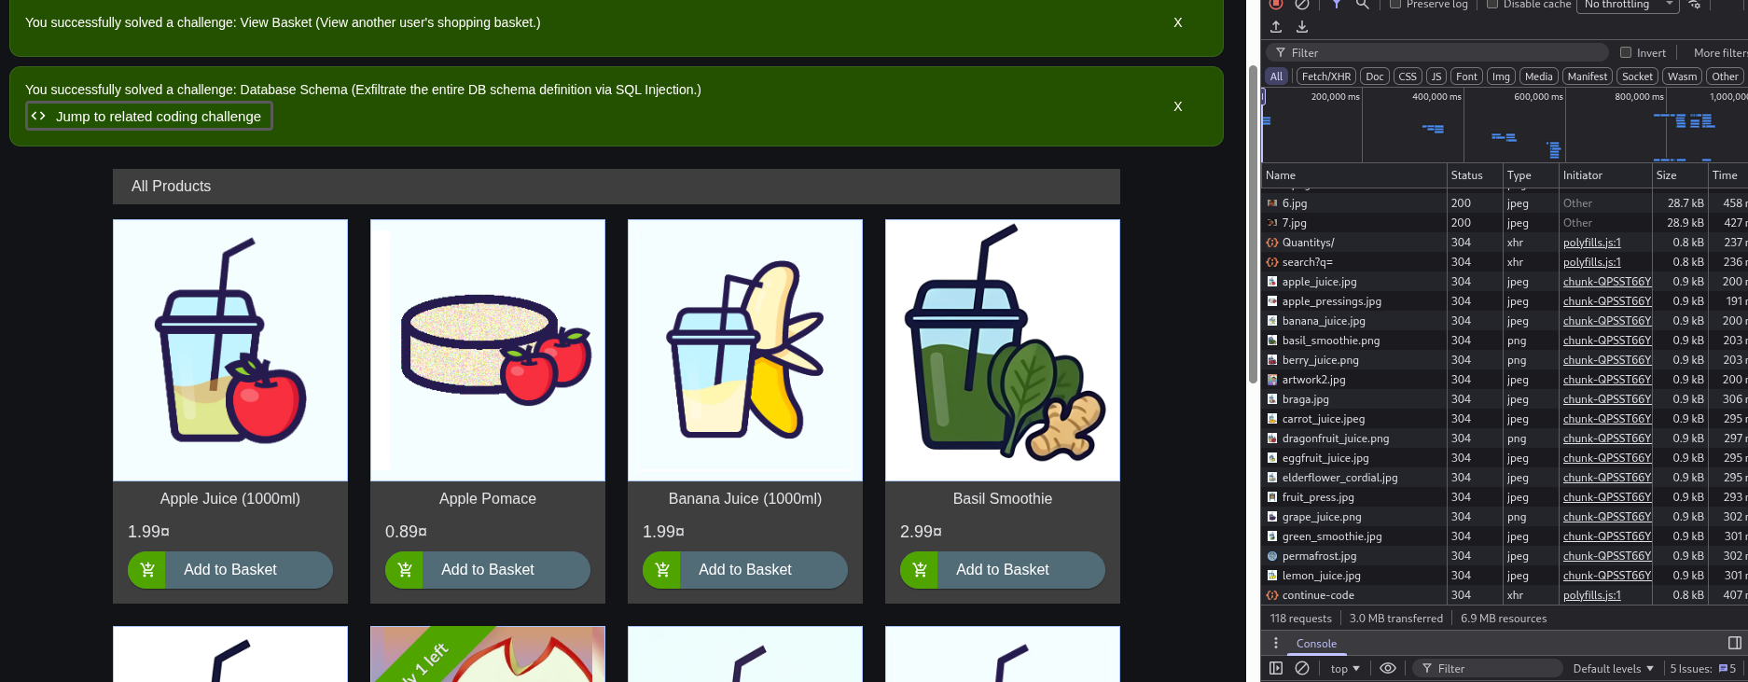
Figure 22 exfiltrate an entire DB schema
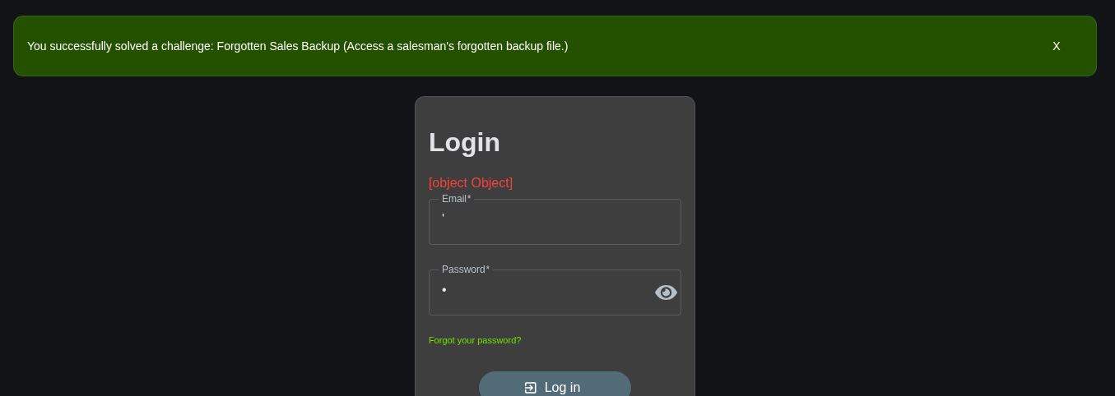
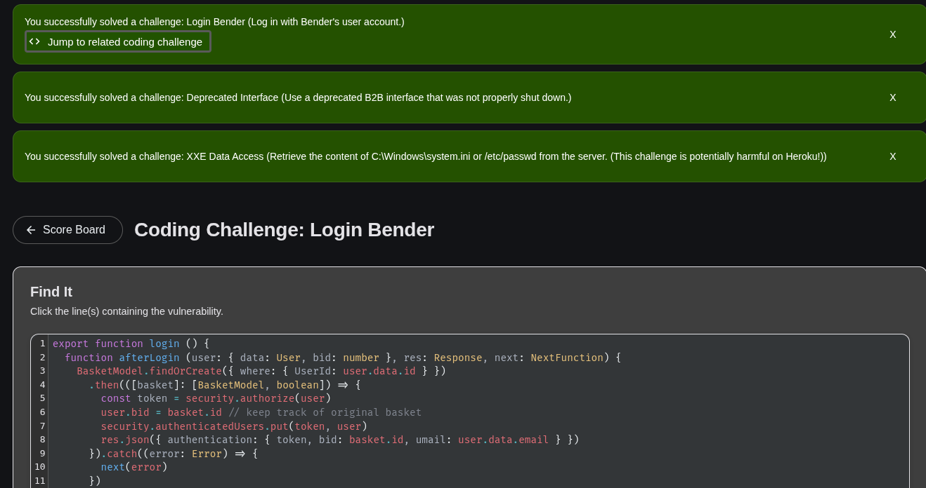
Figure 23 SQL injection on OWASP Juiceshop thus identifying data access retrievaldata access retrieval
Student Reflection
I gained practical experience in exploiting web application vulnerabilities, including brute-force attacks and SQL injection. I successfully identified weaknesses, manipulated queries, and retrieved database information, which strengthened my understanding of attack techniques and the importance of implementing robust security controls.

